Scenario #3: Rate Game

# Description

This test scenario covers a user rating a game, while signed in and being unable to while signed out

# Test Scripts

The following scripts will cover this scenario:

* 1.1. Rate While Signed In
* 1.2. Rate While Signed Out

# Use Case

**1.2. Rate Games**

When authenticated User

Wants to rate a game within the system they can simply do so on the browse page itself

So that they can provide specific ratings to the games they desire and can also post their speak in relation to the

game as feedback

Extends use-case 1.1. (Browse Games)

# Test Components/Requirements

This test scenario covers the following high-level test requirements (see scripts below for specific requirements covered by each test script):

* Authentication
* Persistence
* Game Rating

# User Groups

* Average user

# Script 1: Rate While Signed In

## Description

* An authenticated user will visit any game page (http://violet.blacklotus.cc/game/…)
* User attempts to rate a game
* Observe the result - The game’s average rating should be altered
* User refreshes the page and observes their rating has been persisted

## Setup

* The testing user should ensure they are signed in to a valid account

|  |  |  |  |  |
| --- | --- | --- | --- | --- |
| **Step #** | **Test Step** | **Expected Test Results** | **P** | **F** |
| **1.** | Visit the site’s front page | Site loads with no errors |  |  |
| **2.** | Click any game card from the front page | User is taken to the game page |  |  |
| **3.** | Select a rating that is different to the current game’s average rating and click “Rate” | The average rating displayed is updated to correctly reflect the user’s rating |  |  |
| **4.** | Refresh the page | The average remains at its previously displayed value |  |  |

|  |  |  |  |
| --- | --- | --- | --- |
| Date/Time | Tester | Test Phase | Status |
| 04/10/17 10:15 | Shailesh Jha | Alpha | Passed |

Please refer to the screenshot below:

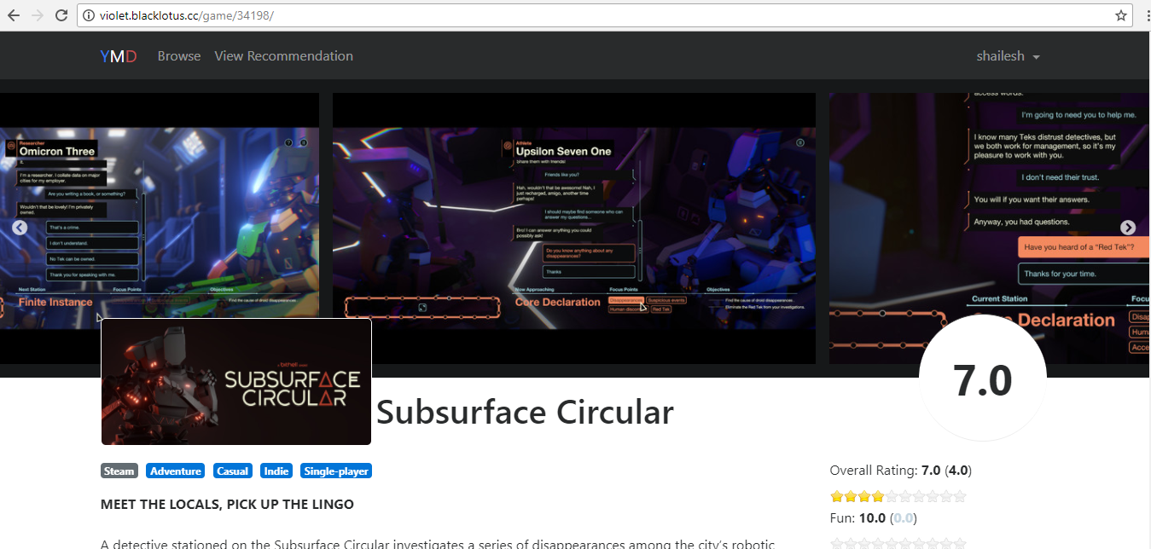

# Script 2: Rate While Signed Out

## Description

* An unauthenticated user will visit any game page (http://violet.blacklotus.cc/game/…)
* User attempts to rate a game
* The user is not permitted to do so

## Setup

* The testing user should ensure they are not signed in to a valid account

|  |  |  |  |  |
| --- | --- | --- | --- | --- |
| **Step #** | **Test Step** | **Expected Test Results** | **P** | **F** |
| **1.** | Visit the site’s front page | Site loads with no errors |  |  |
| **2.** | Click any game card from the front page | User is taken to the game page |  |  |
| **3.** | Attempt to select a rating and click “Rate” | The option to select a rating and rate the game is not available and the user cannot rate the game |  |  |

|  |  |  |  |
| --- | --- | --- | --- |
| Date/Time | Tester | Test Phase | Status |
| 04/10/17 10:25 | Shailesh Jha | Alpha | Passed |

**Please refer to the screenshot below:**

